3soils_markdown

Kaizad Patel

10/19/2019

This is the RMarkdown file for the 3Soils experiment. Tables and figures for molecular results. For formatted tables, see the Word document titled 000-3soils_markdown_YYYYMMDD.docx.

# Soil characterization

## summary table

|  |  |  |  |
| --- | --- | --- | --- |
| **variable** | **CPCRW** | **DWP** | **SR** |
| TC_perc | 1.43 ± 0.21 b | 0.98 ± 0.1 b | 10.32 ± 0.45 a |
| TN_perc | 0.07 ± 0.01 b | 0.04 ± 0 b | 0.59 ± 0.01 a |
| TOC_perc | 1.43 ± 0.19 b | 0.88 ± 0.11 b | 9.94 ± 0.47 a |
| WSOC_mg_g | 1.04 ± 0.28 a | 1 ± 0.16 a | 0.67 ± 0.04 a |
|  |  |  |  |
| Ca_meq100g | 3.52 ± 0.41 b | 0.81 ± 0.11 c | 17.21 ± 0.75 a |
| Mg_meq100g | 1.08 ± 0.09 b | 0.26 ± 0.03 b | 7.56 ± 0.46 a |
| pH | 5.31 ± 0.17 b | 4.79 ± 0.11 c | 5.82 ± 0.05 a |
| EC_dS_m | 0.07 ± 0.01 a | 0.06 ± 0.01 a | - |
|  |  |  |  |
| Sand_perc | 31.8 ± 7.47 b | 90.8 ± 1.74 a | 14 ± 2.12 b |
| Silt_perc | 53 ± 7.36 a | 3.8 ± 0.66 b | 58.5 ± 1.5 a |
| Clay_perc | 15.2 ± 0.37 b | 5.4 ± 1.29 c | 27.75 ± 1.65 a |
| texture | Silt loam | Sand | Silty clay loam |

## pore distribution

## pore size distribution

## water retention curves

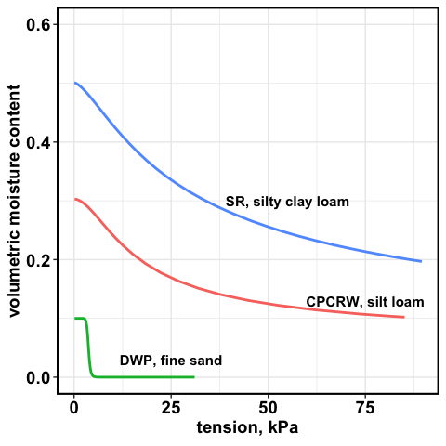

water retention curve

# WSOC tables

## soils

mg/g soil

|  |  |  |  |
| --- | --- | --- | --- |
| **Treatment** | **CPCRW** | **DWP** | **SR** |
| Drought | 0.85 ± 0.2 | 0.72 ± 0.37 | 0.6 ± 0.04 |
| Field Moist | 0.69 ± 0.07 | 0.35 ± 0.05 | 0.61 ± 0.05 |
| Saturated | 0.59 ± 0.05 | 0.39 ± 0.06 | 0.55 ± 0.06 |
| Time Zero | 0.78 ± 0.1 | 0.51 ± 0.08 | 0.43 ± 0.04 |

## 

## pores

mg/L

|  |  |  |  |  |  |  |
| --- | --- | --- | --- | --- | --- | --- |
| **Treatment** | **1.5 kPa CPCRW** | **1.5 kPa DWP** | **1.5 kPa SR** | **50 kPa CPCRW** | **50 kPa DWP** | **50 kPa SR** |
| Drought | 111.82 ± 41.45 * | 69.02 ± 13 | 13.9 ± 2.43 | 186.86 ± 62.65 * | 69.97 ± 13.39 | 19.3 ± 8.32 |
| Field Moist | 21.22 ± 3.73 | 46.33 ± 11.94 | 18.68 ± 2.36 * | 41.17 ± 12.67 | 52.43 ± 14.74 | 19.82 ± 2.93 |
| Saturated | 52.82 ± 13.98 | 42.08 ± 7.34 | 23.16 ± 3.29 * | 63.4 ± 20.84 | 82.7 ± 16.52 | 24.07 ± 2.43 * |
| Time Zero | 26.3 ± 2.78 | 76.68 ± 21.76 | 6.03 ± 0.57 | 29.14 ± 4.41 | 92.33 ± 22.22 | 7.28 ± 0.34 |

## 

## soils, pores combined

*need pore water volume collected*

# FTICR Pores – figures

## native SOM

## Van Krevelen plot for TZSat pores

## treatment effect – all peaks

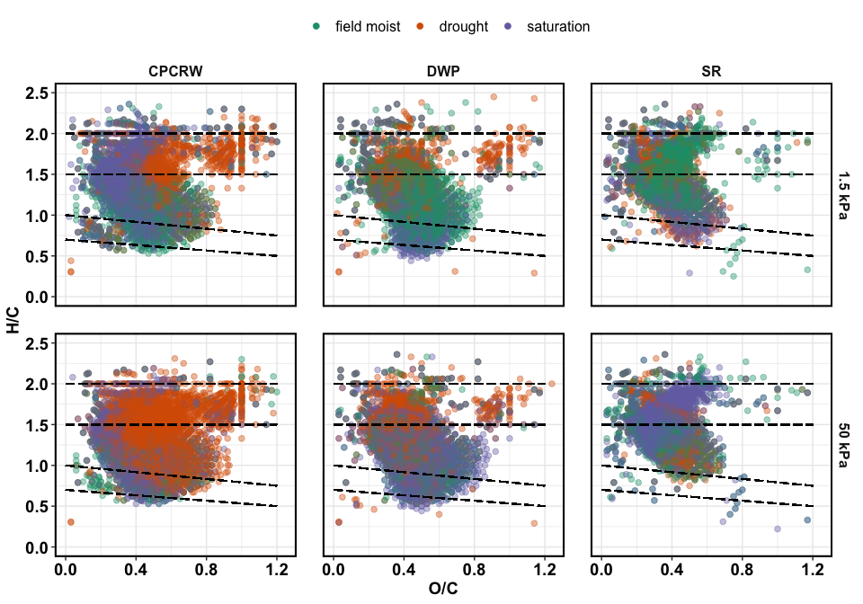

Van Krevelen plot for treatments

## treatment effect – unique peaks

unique in each treatment compared to all, including TZsaturation

these are peaks that were uniquely **added** during a given treatment

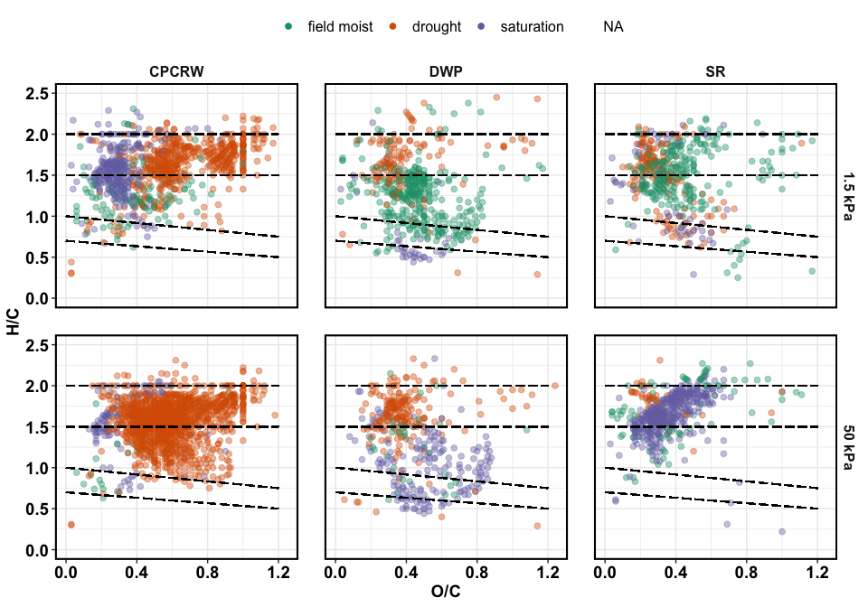

Van Krevelen plot for unique peaks

## treatment effect – relative abundance

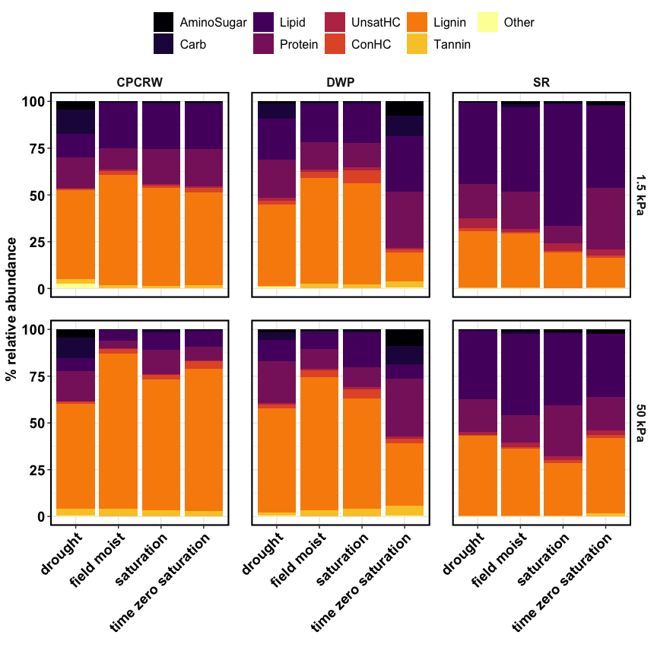

Relative abundance

## treatment effect – NOSC

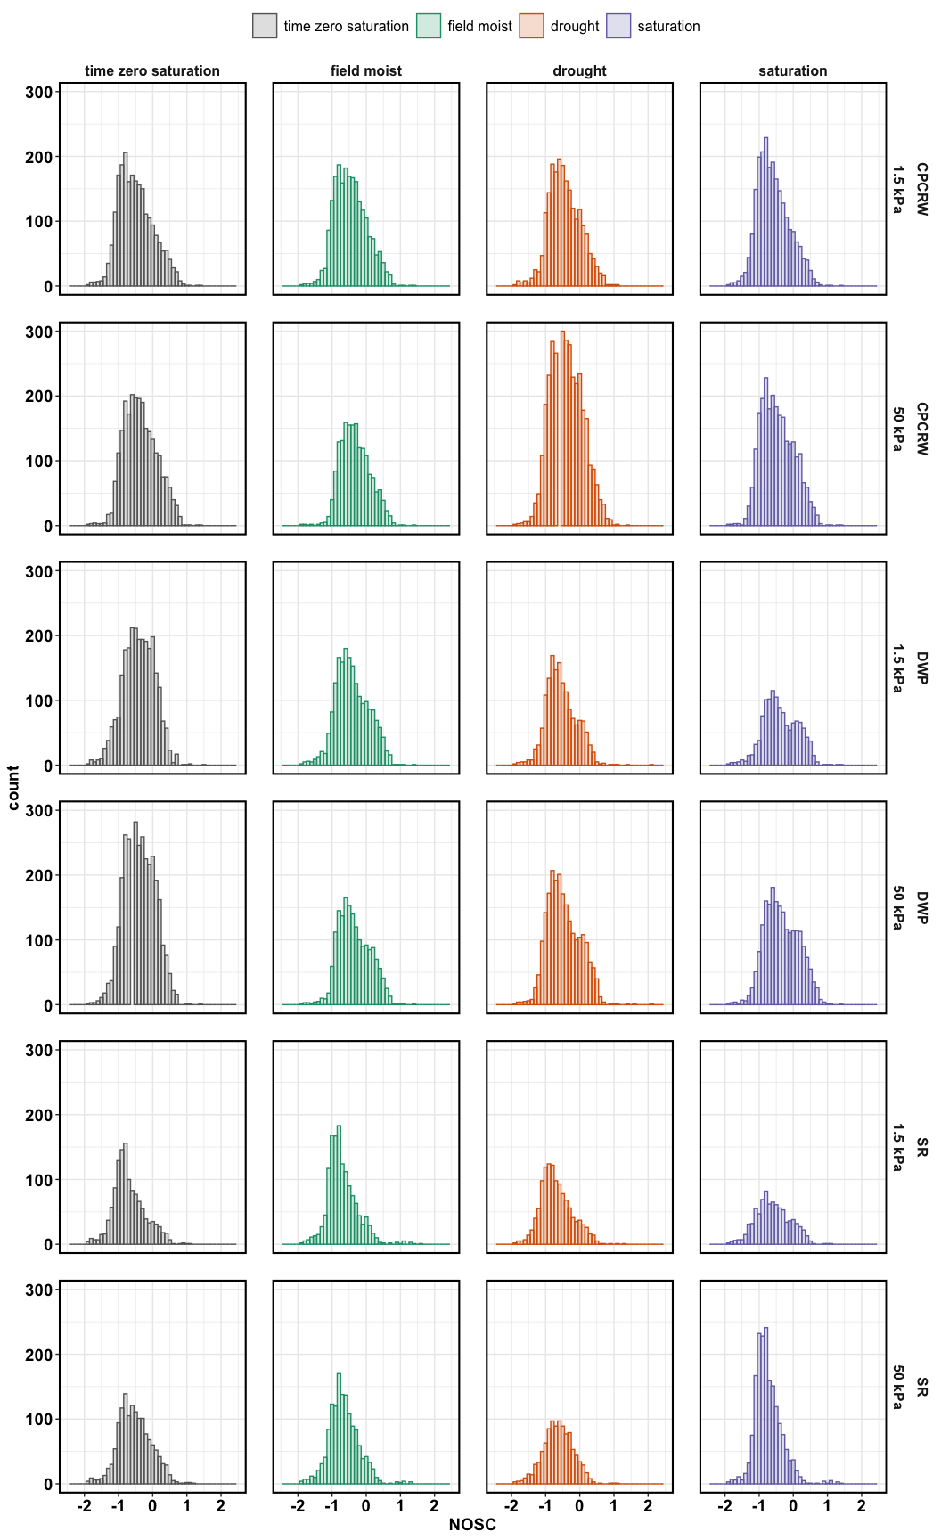

## NOSC medians

|  |  |  |  |  |  |
| --- | --- | --- | --- | --- | --- |
| **tension** | **site** | **drought** | **field moist** | **saturation** | **time zero saturation** |
| 1.5 kPa | CPCRW | -0.5000 | -0.5000 | -0.6429 | -0.5517 |
| 1.5 kPa | DWP | -0.6000 | -0.4615 | -0.4444 | -0.4000 |
| 1.5 kPa | SR | -0.7500 | -0.7742 | -0.6316 | -0.7710 |
| 50 kPa | CPCRW | -0.4286 | -0.3636 | -0.5185 | -0.4000 |
| 50 kPa | DWP | -0.5385 | -0.4189 | -0.4000 | -0.4167 |
| 50 kPa | SR | -0.6316 | -0.6957 | -0.8000 | -0.5600 |

## aromatic peaks

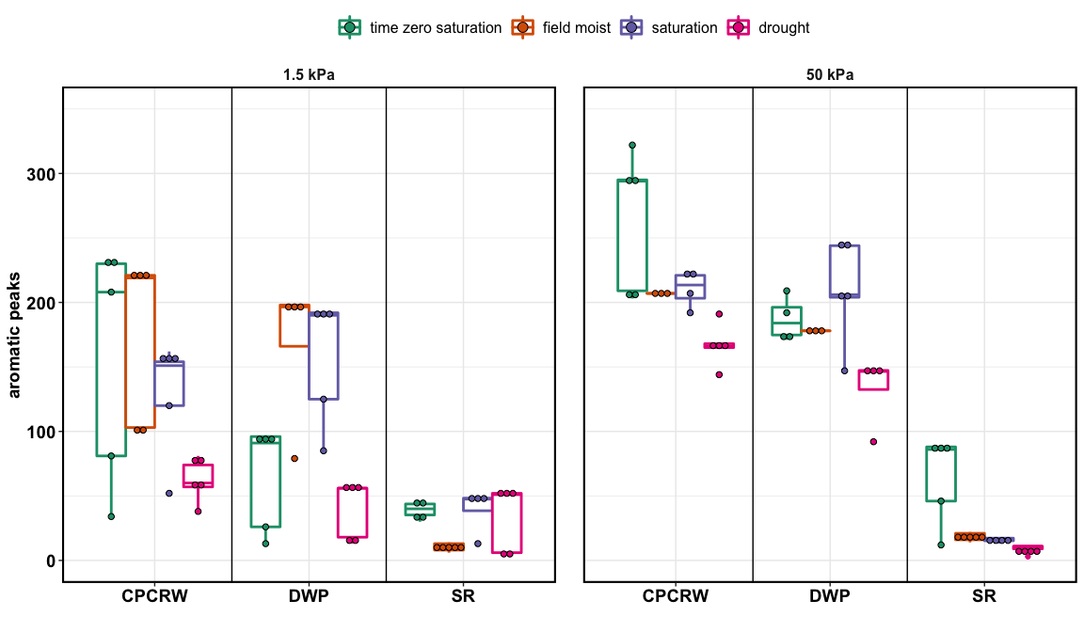

aromatic peaks

# FTICR Pores – tables

## Peaks ## [1] "50 kPa"

|  |  |  |  |  |
| --- | --- | --- | --- | --- |
| **Class** | **drought** | **field moist** | **saturation** | **time zero saturation** |
| **CPCRW** |  |  |  |  |
| AminoSugar | 243 | 9 | 28 | 23 |
| Carb | 301 | 13 | 60 | 26 |
| Lipid | 184 | 44 | 193 | 142 |
| Protein | 661 | 85 | 404 | 210 |
| UnsatHC | 4 | 9 | 3 | 11 |
| ConHC | 139 | 136 | 151 | 248 |
| Lignin | 1948 | 1333 | 1583 | 1686 |
| Tannin | 236 | 95 | 119 | 121 |
| Other | 15 | 9 | 2 | 11 |
| total | 3731 | 1733 | 2543 | 2478 |
| **DWP** |  |  |  |  |
| AminoSugar | 45 | 26 | 33 | 305 |
| Carb | 85 | 8 | 30 | 319 |
| Lipid | 161 | 65 | 118 | 172 |
| Protein | 481 | 202 | 271 | 687 |
| UnsatHC | 6 | 3 | 10 | 19 |
| ConHC | 106 | 132 | 195 | 151 |
| Lignin | 1297 | 1208 | 1321 | 1529 |
| Tannin | 79 | 106 | 151 | 206 |
| Other | 12 | 2 | 3 | 22 |
| total | 2272 | 1752 | 2132 | 3410 |
| **SR** |  |  |  |  |
| AminoSugar | 6 | 31 | 67 | 37 |
| Carb | 7 | 21 | 13 | 6 |
| Lipid | 145 | 214 | 272 | 129 |
| Protein | 253 | 270 | 570 | 294 |
| UnsatHC | 5 | 19 | 17 | 19 |
| ConHC | 3 | 14 | 16 | 63 |
| Lignin | 606 | 826 | 834 | 849 |
| Tannin | 4 | 11 | 10 | 31 |
| Other | 2 | 5 | 4 | 3 |
| total | 1031 | 1411 | 1803 | 1431 |

## Peaks ## [1] "1.5 kPa"

|  |  |  |  |  |
| --- | --- | --- | --- | --- |
| **Class** | **drought** | **field moist** | **saturation** | **time zero saturation** |
| **CPCRW** |  |  |  |  |
| AminoSugar | 142 | 21 | 31 | 42 |
| Carb | 201 | 28 | 32 | 19 |
| Lipid | 114 | 143 | 253 | 167 |
| Protein | 429 | 313 | 489 | 494 |
| UnsatHC | 4 | 17 | 15 | 18 |
| ConHC | 54 | 143 | 95 | 172 |
| Lignin | 1055 | 1409 | 1323 | 1277 |
| Tannin | 98 | 94 | 63 | 93 |
| Other | 30 | 9 | 11 | 7 |
| total | 2127 | 2177 | 2312 | 2289 |
| **DWP** |  |  |  |  |
| AminoSugar | 32 | 27 | 5 | 300 |
| Carb | 88 | 11 | 14 | 363 |
| Lipid | 132 | 128 | 83 | 145 |
| Protein | 355 | 272 | 149 | 600 |
| UnsatHC | 5 | 10 | 8 | 16 |
| ConHC | 36 | 152 | 152 | 60 |
| Lignin | 895 | 1265 | 819 | 946 |
| Tannin | 18 | 98 | 42 | 152 |
| Other | 14 | 7 | 3 | 32 |
| total | 1575 | 1970 | 1275 | 2614 |
| **SR** |  |  |  |  |
| AminoSugar | 20 | 56 | 16 | 49 |
| Carb | 4 | 26 | 10 | 11 |
| Lipid | 222 | 203 | 135 | 167 |
| Protein | 316 | 458 | 122 | 424 |
| UnsatHC | 15 | 13 | 25 | 20 |
| ConHC | 27 | 13 | 26 | 34 |
| Lignin | 597 | 635 | 521 | 543 |
| Tannin | 11 | 10 | 10 | 11 |
| Other | 3 | 5 | - | 5 |
| total | 1215 | 1419 | 865 | 1264 |

## unique peaks ## [1] "50 kPa"

|  |  |  |  |
| --- | --- | --- | --- |
| **Class** | **drought** | **field moist** | **saturation** |
| **CPCRW** |  |  |  |
| AminoSugar | 217 | - | 2 |
| Carb | 240 | 1 | - |
| Lipid | 26 | 1 | 28 |
| Protein | 282 | - | 24 |
| UnsatHC | - | 2 | - |
| ConHC | 6 | 4 | 4 |
| Lignin | 328 | 12 | 38 |
| Tannin | 104 | - | 5 |
| Other | 10 | - | - |
| **DWP** |  |  |  |
| AminoSugar | 5 | 2 | 3 |
| Carb | 8 | - | - |
| Lipid | 31 | - | 12 |
| Protein | 93 | 7 | 6 |
| UnsatHC | - | - | 2 |
| ConHC | 6 | 5 | 57 |
| Lignin | 45 | 14 | 67 |
| Tannin | 1 | 2 | 32 |
| Other | 5 | - | - |
| **SR** |  |  |  |
| AminoSugar | - | 11 | 23 |
| Carb | 2 | 10 | 1 |
| Lipid | 30 | 18 | 70 |
| Protein | 11 | 17 | 175 |
| UnsatHC | - | 3 | 2 |
| ConHC | - | - | 4 |
| Lignin | 2 | 26 | 91 |
| Tannin | - | - | 3 |
| Other | - | 2 | 2 |

## unique peaks ## [1] "1.5 kPa"

|  |  |  |  |
| --- | --- | --- | --- |
| **Class** | **drought** | **field moist** | **saturation** |
| **CPCRW** |  |  |  |
| AminoSugar | 118 | - | 3 |
| Carb | 177 | 4 | 3 |
| Lipid | 8 | 5 | 88 |
| Protein | 86 | 16 | 61 |
| UnsatHC | - | 7 | 3 |
| ConHC | 6 | 3 | 3 |
| Lignin | 71 | 102 | 107 |
| Tannin | 15 | 6 | - |
| Other | 19 | - | - |
| **DWP** |  |  |  |
| AminoSugar | 7 | 7 | - |
| Carb | 6 | 3 | - |
| Lipid | 25 | 16 | 4 |
| Protein | 49 | 15 | - |
| UnsatHC | - | 5 | 3 |
| ConHC | 4 | 29 | 27 |
| Lignin | 23 | 230 | 2 |
| Tannin | 1 | 34 | - |
| Other | 6 | 4 | - |
| **SR** |  |  |  |
| AminoSugar | - | 14 | 3 |
| Carb | - | 16 | 1 |
| Lipid | 63 | 22 | 9 |
| Protein | 25 | 81 | 9 |
| UnsatHC | - | - | 6 |
| ConHC | 8 | 10 | 8 |
| Lignin | 59 | 96 | 19 |
| Tannin | 4 | 5 | 1 |
| Other | 1 | 4 | - |

## 

## relative abundance ## [1] "50 kPa"

asterisks = statistically different from time zero saturation

|  |  |  |  |  |
| --- | --- | --- | --- | --- |
| **Class** | **drought** | **field moist** | **saturation** | **time zero saturation** |
| **CPCRW** |  |  |  |  |
| AminoSugar | 4.35 ± 0.66 * | 0.2 ± 0 | 0.53 ± 0.06 | 0.37 ± 0.02 |
| Carb | 10.91 ± 2.17 * | 0.31 ± 0.01 | 0.9 ± 0.25 | 0.42 ± 0.05 |
| Lipid | 7.07 ± 1.09 | 5.52 ± 2.18 | 9.61 ± 1.49 | 8.66 ± 1.76 |
| Protein | 16.11 ± 1.74 * | 3.97 ± 0.08 | 12.8 ± 0.71 * | 7 ± 0.8 |
| UnsatHC | 0.1 ± 0.03 | 0.36 ± 0.04 | 0.59 ± 0.44 | 0.66 ± 0.32 |
| ConHC | 1.37 ± 0.34 * | 2.58 ± 0.51 | 2.5 ± 0.45 | 4.14 ± 1.04 |
| Lignin | 56.09 ± 2.88 * | 82.96 ± 1.55 | 69.89 ± 1.46 | 75.73 ± 2.43 |
| Tannin | 3.37 ± 0.46 | 3.93 ± 0.92 | 3.14 ± 0.6 | 2.88 ± 0.43 |
| Other | 0.63 ± 0.17 | 0.16 ± 0.02 | 0.04 ± 0 | 0.13 ± 0.04 |
| **DWP** |  |  |  |  |
| AminoSugar | 1.38 ± 0.38 * | 0.79 ± 0.07 * | 0.61 ± 0.12 * | 8.79 ± 1.49 |
| Carb | 4.06 ± 1.1 * | 0.33 ± 0.01 * | 0.86 ± 0.15 * | 9.91 ± 1.31 |
| Lipid | 11.53 ± 1.44 | 9.36 ± 1.09 | 18.88 ± 10.45 | 7.74 ± 2.81 |
| Protein | 22.26 ± 2 * | 10.7 ± 1.54 * | 10.55 ± 1.35 * | 30.92 ± 3.15 |
| UnsatHC | 0.76 ± 0.32 | 0.87 ± 0.32 | 1.18 ± 0.53 | 1.21 ± 0.33 |
| ConHC | 2.35 ± 0.33 | 3.66 ± 0.85 | 4.96 ± 1.11 | 2.47 ± 0.26 |
| Lignin | 55.56 ± 2.55 | 71.02 ± 2.08 * | 58.9 ± 9.08 * | 33.19 ± 3.36 |
| Tannin | 1.52 ± 0.21 * | 3.16 ± 0.46 | 3.95 ± 0.93 | 5.18 ± 0.31 |
| Other | 0.58 ± 0.08 | 0.11 ± 0.02 | 0.11 ± 0.03 | 0.59 ± 0.06 |
| **SR** |  |  |  |  |
| AminoSugar | 0.31 ± 0.09 | 1.24 ± 0.24 | 1.66 ± 0.34 | 2.18 ± 1.37 |
| Carb | 0.3 ± 0.05 | 1.03 ± 0.54 | 0.38 ± 0.03 | 0.17 ± 0.02 |
| Lipid | 36.81 ± 7.51 | 43.72 ± 6.42 | 38.67 ± 7 | 33.89 ± 9.83 |
| Protein | 17.24 ± 4.14 | 14.49 ± 2.04 | 27 ± 3.64 | 17.71 ± 5.26 |
| UnsatHC | 1.81 ± 0.79 | 2.55 ± 0.35 | 2.33 ± 0.46 | 2.56 ± 0.89 |
| ConHC | 0.42 ± 0.19 | 0.51 ± 0.15 | 1.25 ± 0.52 | 1.44 ± 0.32 |
| Lignin | 42.7 ± 8.42 | 36.06 ± 5.64 | 28.39 ± 4.35 | 40.32 ± 11.73 |
| Tannin | 0.25 ± 0.15 | 0.26 ± 0.07 | 0.22 ± 0.05 | 1.54 ± 1.01 |
| Other | 0.16 ± 0.05 | 0.13 ± 0.03 | 0.11 ± 0.04 | 0.2 ± 0.05 |

total = 100%

## relative abundance ## [1] "1.5 kPa"

asterisks = statistically different from time zero saturation

|  |  |  |  |  |
| --- | --- | --- | --- | --- |
| **Class** | **drought** | **field moist** | **saturation** | **time zero saturation** |
| **CPCRW** |  |  |  |  |
| AminoSugar | 4.3 ± 0.52 * | 0.33 ± 0.05 | 0.54 ± 0.1 | 0.82 ± 0.12 |
| Carb | 13.15 ± 2.28 * | 0.4 ± 0.08 | 0.46 ± 0.05 | 0.36 ± 0.05 |
| Lipid | 12.44 ± 5.18 | 24.17 ± 8.26 | 24.29 ± 2.66 | 24.23 ± 4.1 |
| Protein | 16.57 ± 1.96 | 11.57 ± 1.44 * | 18.95 ± 2.03 | 19.93 ± 2.86 |
| UnsatHC | 0.15 ± 0.05 * | 0.65 ± 0.09 | 0.68 ± 0.18 | 0.96 ± 0.21 |
| ConHC | 1.02 ± 0.23 | 2.26 ± 0.21 | 1.36 ± 0.42 | 2.55 ± 0.68 |
| Lignin | 47.39 ± 6.34 | 58.67 ± 9.42 | 52.55 ± 3.27 | 49.34 ± 5.81 |
| Tannin | 2.28 ± 0.57 | 1.85 ± 0.21 | 1.04 ± 0.21 | 1.75 ± 0.27 |
| Other | 2.71 ± 1.85 | 0.12 ± 0.03 | 0.13 ± 0.02 | 0.08 ± 0.01 |
| **DWP** |  |  |  |  |
| AminoSugar | 1.03 ± 0.16 * | 0.66 ± 0.11 * | 0.28 ± 0.1 * | 7.76 ± 2.46 |
| Carb | 8.32 ± 1.22 | 0.32 ± 0.03 * | 0.8 ± 0.24 * | 10.99 ± 3.48 |
| Lipid | 21.63 ± 3.13 | 20.84 ± 1.54 | 21.17 ± 5.37 | 29.39 ± 12.34 |
| Protein | 20.41 ± 2.14 * | 14.44 ± 1.13 * | 12.93 ± 2.3 * | 30.07 ± 2.2 |
| UnsatHC | 1.57 ± 1.11 | 1.53 ± 0.36 | 1.66 ± 0.26 | 0.97 ± 0.15 |
| ConHC | 2.3 ± 0.29 | 3.1 ± 0.91 | 6.98 ± 1.16 * | 1.66 ± 0.54 |
| Lignin | 43.38 ± 4.12 * | 56.46 ± 1.95 * | 54.11 ± 7.25 * | 15.26 ± 3.77 |
| Tannin | 0.44 ± 0.1 * | 2.46 ± 0.25 | 1.92 ± 0.51 | 3.15 ± 1.06 |
| Other | 0.9 ± 0.12 | 0.19 ± 0.04 | 0.17 ± 0.03 | 0.75 ± 0.24 |
| **SR** |  |  |  |  |
| AminoSugar | 0.66 ± 0.23 | 1.63 ± 0.5 | 0.59 ± 0.12 | 1.84 ± 0.3 |
| Carb | 0.13 ± 0.02 | 1.61 ± 0.61 | 0.79 ± 0.3 | 0.51 ± 0.08 |
| Lipid | 43.37 ± 1.9 | 44.84 ± 11.52 | 65.05 ± 3.58 | 43.82 ± 6.28 |
| Protein | 18.58 ± 1.49 * | 20.2 ± 4.83 | 9.49 ± 0.92 * | 33.15 ± 5.46 |
| UnsatHC | 5.05 ± 1.66 | 1.56 ± 0.21 | 4.06 ± 0.85 | 2.9 ± 0.81 |
| ConHC | 1.52 ± 0.45 | 0.71 ± 0.34 | 0.58 ± 0.12 | 1.29 ± 0.31 |
| Lignin | 30.2 ± 2.11 | 28.94 ± 10.2 | 19.26 ± 2.9 | 15.94 ± 0.84 |
| Tannin | 0.37 ± 0.09 | 0.42 ± 0.11 | 0.18 ± 0.06 | 0.21 ± 0.05 |
| Other | 0.26 ± 0.1 | 0.11 ± 0.02 | - | 0.35 ± 0.15 |

total = 100%

# FTICR Soil – figures

## native SOM

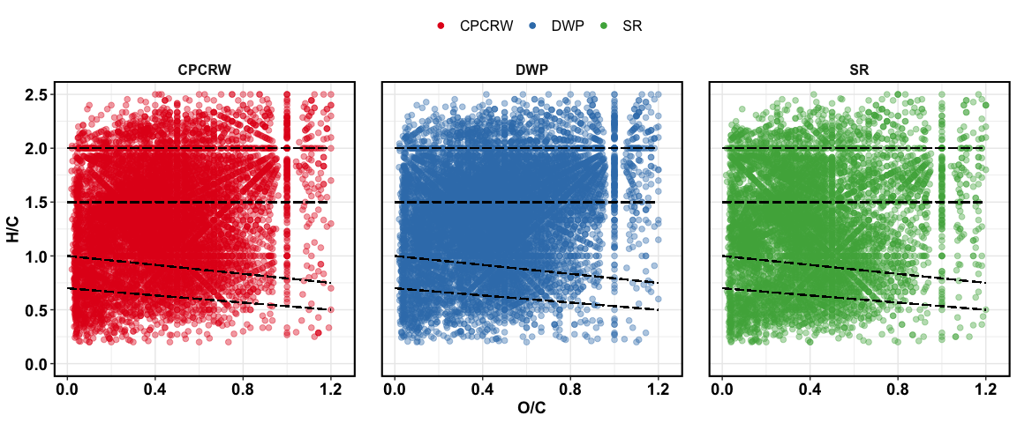

Van Krevelen plot for baseline soil

## treatment effect – all peaks

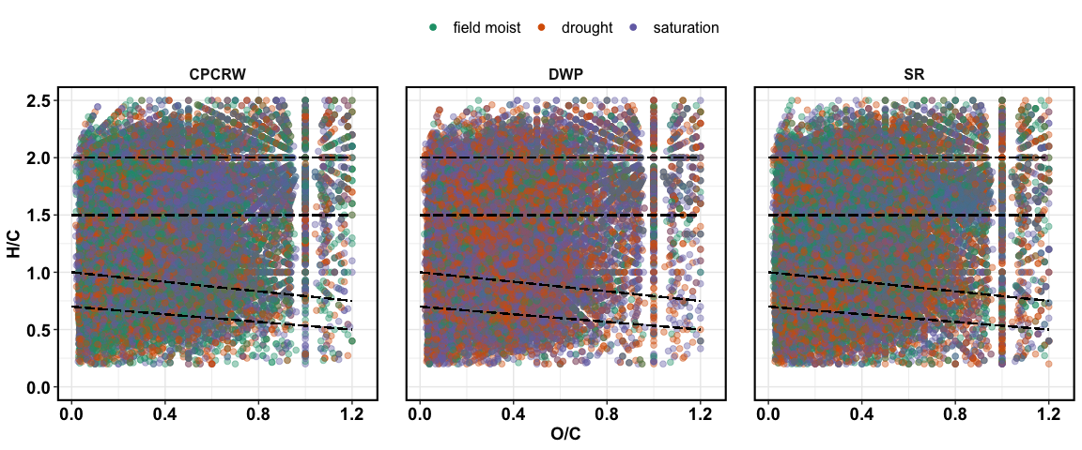

Van Krevelen plot for treatments

## treatment effect – unique peaks

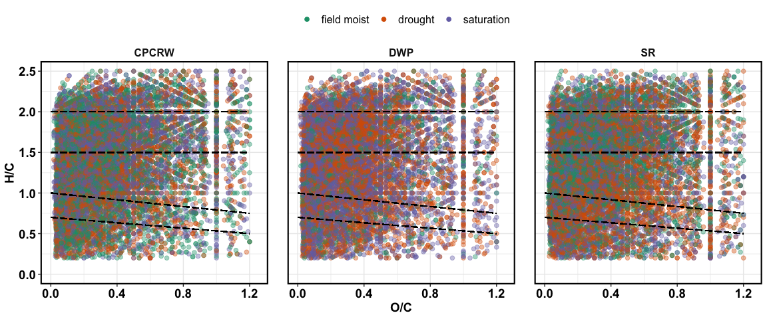

Van Krevelen plot for unique peaks

## treatment effect – relative abundance

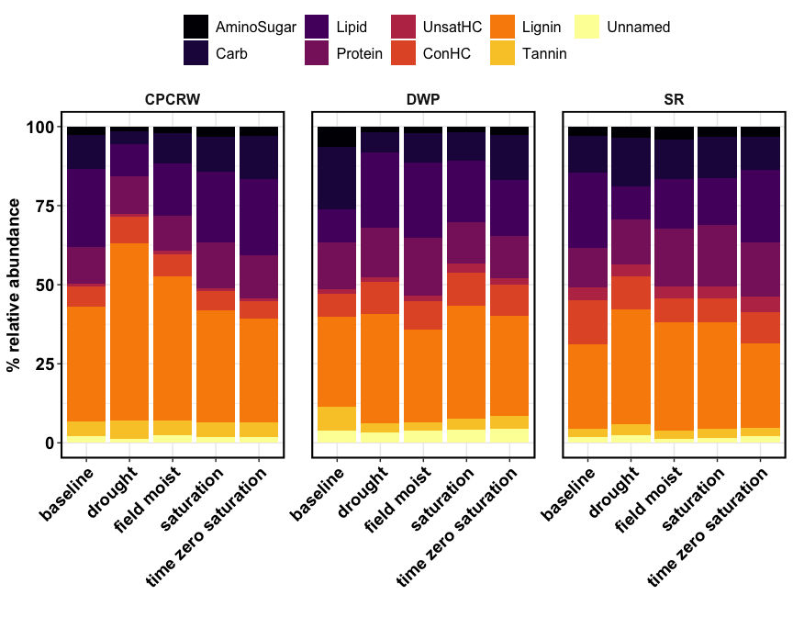

Relative abundance

## NOSC

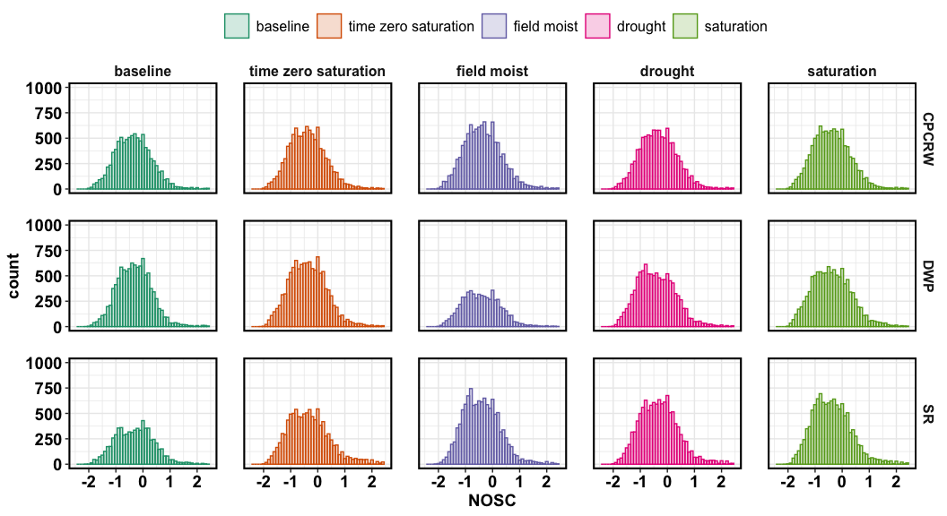

## 

## NOSC median

|  |  |  |  |  |  |
| --- | --- | --- | --- | --- | --- |
| **site** | **baseline** | **drought** | **field moist** | **saturation** | **time zero saturation** |
| CPCRW | -0.3636 | -0.3529 | -0.3846 | -0.4211 | -0.4000 |
| DWP | -0.3200 | -0.4545 | -0.4444 | -0.4211 | -0.3871 |
| SR | -0.2963 | -0.3333 | -0.4444 | -0.4286 | -0.3750 |

## 

## aromatic peaks

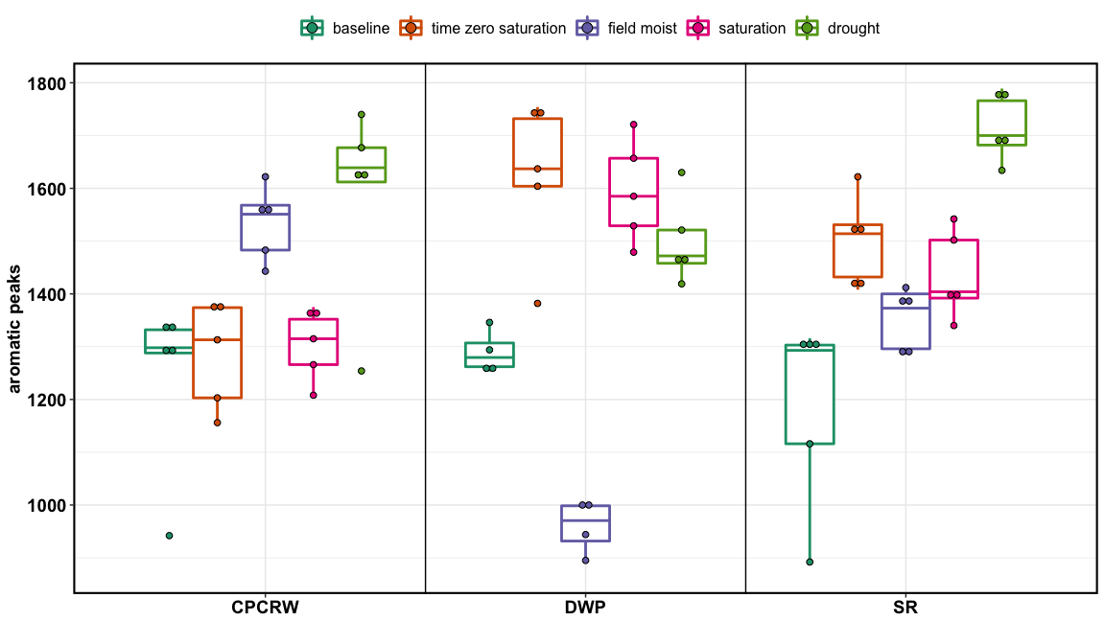

aromatic peaks

# FTICR Soil – tables

## relative abundance

asterisks = statistically different from baseline

|  |  |  |  |  |  |
| --- | --- | --- | --- | --- | --- |
| **Class** | **baseline** | **drought** | **field moist** | **saturation** | **time zero saturation** |
| **CPCRW** |  |  |  |  |  |
| AminoSugar | 2.69 ± 0.32 | 1.48 ± 0.12 | 2.19 ± 0.48 | 3.37 ± 0.34 | 2.94 ± 0.35 |
| Carb | 10.82 ± 1.88 | 4.17 ± 0.92 * | 9.6 ± 2.33 | 10.78 ± 1.06 | 13.53 ± 1.87 |
| Lipid | 24.65 ± 3.11 | 10.11 ± 1.93 * | 16.35 ± 3.94 | 22.37 ± 0.85 | 24.32 ± 3.62 |
| Protein | 11.59 ± 1 | 11.91 ± 1.2 | 11.18 ± 0.5 | 14.69 ± 1.18 | 13.63 ± 1.63 |
| UnsatHC | 0.69 ± 0.07 | 0.84 ± 0.09 | 1 ± 0.12 | 0.93 ± 0.08 | 0.83 ± 0.06 |
| ConHC | 6.45 ± 0.92 | 8.29 ± 1.21 | 7.07 ± 0.6 | 6.01 ± 0.53 | 5.46 ± 0.63 |
| Lignin | 36.24 ± 0.71 | 56.17 ± 3.13 * | 45.5 ± 5.07 | 35.47 ± 1.45 | 32.94 ± 2.75 |
| Tannin | 4.79 ± 0.45 | 5.92 ± 0.29 | 4.61 ± 0.52 | 4.57 ± 0.25 | 4.44 ± 0.94 |
| Unnamed | 2.08 ± 0.34 | 1.12 ± 0.07 | 2.5 ± 0.42 | 1.8 ± 0.23 | 1.91 ± 0.18 |
| **DWP** |  |  |  |  |  |
| AminoSugar | 6.49 ± 0.45 | 1.82 ± 0.18 * | 2.05 ± 0.13 * | 1.74 ± 0.2 * | 2.75 ± 0.24 |
| Carb | 19.77 ± 0.65 | 6.38 ± 0.94 * | 9.32 ± 0.53 * | 9 ± 1.02 * | 14.22 ± 1.66 |
| Lipid | 10.43 ± 0.35 | 23.73 ± 2.62 * | 23.71 ± 2.24 * | 19.37 ± 2.09 | 17.52 ± 3.12 |
| Protein | 14.6 ± 1.09 | 15.61 ± 0.61 | 18.52 ± 1.89 | 13.29 ± 1.26 | 13.4 ± 0.76 |
| UnsatHC | 1.53 ± 0.29 | 1.54 ± 0.24 | 1.57 ± 0.16 | 2.74 ± 0.41 * | 2.05 ± 0.33 |
| ConHC | 7.27 ± 0.47 | 10.05 ± 0.47 | 9.14 ± 0.97 | 10.54 ± 1.27 * | 9.77 ± 0.37 |
| Lignin | 28.57 ± 1.26 | 34.54 ± 1.86 | 29.34 ± 2.83 | 35.62 ± 2.3 | 31.76 ± 4.2 |
| Tannin | 7.43 ± 0.33 | 3.11 ± 0.47 * | 2.58 ± 0.7 * | 3.52 ± 0.41 * | 4.06 ± 0.23 |
| Unnamed | 3.92 ± 0.08 | 3.21 ± 0.33 | 3.77 ± 0.18 | 4.18 ± 0.1 | 4.47 ± 0.5 |
| **SR** |  |  |  |  |  |
| AminoSugar | 2.82 ± 0.26 | 3.45 ± 0.32 | 4.16 ± 0.16 * | 3.37 ± 0.1 | 3.16 ± 0.27 |
| Carb | 11.72 ± 1.38 | 15.55 ± 1.14 * | 12.38 ± 0.83 | 12.8 ± 0.78 | 10.39 ± 0.75 |
| Lipid | 23.96 ± 3.3 | 10.45 ± 1.02 * | 15.64 ± 1.3 * | 15.05 ± 0.78 * | 23.02 ± 3.09 |
| Protein | 12.49 ± 1.39 | 14.27 ± 1.97 | 18.22 ± 2.84 | 19.2 ± 1.84 | 17.12 ± 1.06 |
| UnsatHC | 4 ± 0.29 | 3.61 ± 0.74 | 4 ± 0.33 | 4 ± 0.8 | 5 ± 0.73 |
| ConHC | 13.77 ± 0.89 | 10.45 ± 0.75 | 7.44 ± 1.61 * | 7.59 ± 1.09 * | 9.72 ± 0.69 |
| Lignin | 26.8 ± 2.15 | 36.4 ± 2.72 * | 34.19 ± 1.33 * | 33.55 ± 1.68 | 26.88 ± 1.05 |
| Tannin | 2.74 ± 0.26 | 3.33 ± 0.46 | 2.64 ± 0.26 | 2.94 ± 0.22 | 2.68 ± 0.15 |
| Unnamed | 1.72 ± 0.12 | 2.48 ± 0.14 * | 1.33 ± 0.13 | 1.49 ± 0.2 | 2.03 ± 0.2 |

TOTAL = 100%

## Peaks

|  |  |  |  |  |  |
| --- | --- | --- | --- | --- | --- |
| **Class** | **baseline** | **drought** | **field moist** | **saturation** | **time zero saturation** |
| **CPCRW** |  |  |  |  |  |
| AminoSugar | 495 | 431 | 523 | 587 | 540 |
| Carb | 554 | 472 | 603 | 675 | 655 |
| Lipid | 914 | 1056 | 1304 | 1353 | 1226 |
| Protein | 1313 | 1366 | 1528 | 1627 | 1527 |
| UnsatHC | 427 | 608 | 618 | 577 | 544 |
| ConHC | 1358 | 1684 | 1711 | 1379 | 1376 |
| Lignin | 3032 | 3414 | 3596 | 3237 | 3156 |
| Tannin | 587 | 603 | 598 | 585 | 563 |
| Unnamed | 385 | 428 | 463 | 436 | 391 |
| total | 9065 | 10062 | 10944 | 10456 | 9978 |
| **DWP** |  |  |  |  |  |
| AminoSugar | 742 | 435 | 291 | 448 | 615 |
| Carb | 994 | 476 | 369 | 589 | 774 |
| Lipid | 990 | 1462 | 841 | 1555 | 1447 |
| Protein | 1480 | 1653 | 982 | 1458 | 1615 |
| UnsatHC | 461 | 632 | 308 | 716 | 683 |
| ConHC | 1272 | 1649 | 923 | 1787 | 1839 |
| Lignin | 3215 | 3088 | 1868 | 3191 | 3551 |
| Tannin | 706 | 425 | 259 | 523 | 596 |
| Unnamed | 406 | 415 | 223 | 454 | 486 |
| total | 10266 | 10235 | 6064 | 10721 | 11606 |
| **SR** |  |  |  |  |  |
| AminoSugar | 247 | 552 | 625 | 607 | 427 |
| Carb | 373 | 631 | 776 | 755 | 495 |
| Lipid | 835 | 1220 | 1546 | 1505 | 1316 |
| Protein | 836 | 1618 | 1725 | 1782 | 1406 |
| UnsatHC | 410 | 651 | 767 | 770 | 687 |
| ConHC | 1368 | 2000 | 1503 | 1621 | 1737 |
| Lignin | 2111 | 3758 | 3702 | 3651 | 2951 |
| Tannin | 362 | 607 | 536 | 547 | 510 |
| Unnamed | 252 | 504 | 448 | 461 | 481 |
| total | 6794 | 11541 | 11628 | 11699 | 10010 |

## unique peaks

peaks that were not in the baseline samples, but were uniquely added to one of these three treatments.

|  |  |  |  |
| --- | --- | --- | --- |
| **Class** | **drought** | **field moist** | **saturation** |
| **CPCRW** |  |  |  |
| AminoSugar | 153 | 161 | 166 |
| Carb | 150 | 190 | 209 |
| Lipid | 513 | 659 | 674 |
| Protein | 469 | 484 | 552 |
| UnsatHC | 289 | 284 | 298 |
| ConHC | 634 | 650 | 440 |
| Lignin | 965 | 1012 | 844 |
| Tannin | 157 | 147 | 149 |
| Unnamed | 202 | 221 | 210 |
| **DWP** |  |  |  |
| AminoSugar | 147 | 72 | 140 |
| Carb | 125 | 71 | 184 |
| Lipid | 734 | 271 | 832 |
| Protein | 627 | 194 | 515 |
| UnsatHC | 329 | 123 | 386 |
| ConHC | 620 | 236 | 735 |
| Lignin | 962 | 323 | 1043 |
| Tannin | 151 | 58 | 189 |
| Unnamed | 222 | 84 | 251 |
| **SR** |  |  |  |
| AminoSugar | 196 | 171 | 172 |
| Carb | 211 | 184 | 168 |
| Lipid | 541 | 690 | 647 |
| Protein | 517 | 522 | 521 |
| UnsatHC | 257 | 319 | 332 |
| ConHC | 851 | 511 | 632 |
| Lignin | 1110 | 966 | 964 |
| Tannin | 246 | 147 | 175 |
| Unnamed | 253 | 211 | 221 |

# Aromaticity Index

Corrected AI_mod from Koch and Dittmar 2015: values range from -inf to +inf.

# 